VILLAGE OF STOCKBRIDGE MICHIGAN DOWNTOWN DEVELPOMENT AUTHORTY
STATE OF MICHIGAN SECOND OF TWO REQUIRED INFORMATIONAL MEETING Presented on March 23, 2023
January 1st, 2022, to December 31, 2022
The Village of Stockbridge Downtown Development Authority (SDDA)
Tax increment financing is a government financing program that contributes to economic growth and development by dedicating a portion of the increase in the tax base resulting from economic growth and development to facilities, structures, or improvements within a development area thereby facilitating economic growth and development, eliminate property value deterioration. Halting property value deterioration.

Tax increment financing permits the Stockbridge Downtown Development Authority (SDDA) to capture Tax Increment Financing Revenues (as defined below) attributable to increases in value of real and personal property in the development area. The tax increment finance procedure was governed by act 197 of the Public acts of 1975 which has been replaced by act 57 of Public act of 2018 re-codified as amended (the “DDA Act”) The procedures outlined below are the procedures provided by the DDA Act effective as the date of this plan ( January 01, 2019) is adopted but are subject to any changes imposed by future amendments to the DDA Act.
The Tax Increment Revenues are generated when the Current Assessed Value of all properties within the Development area (TIFD) exceed the initial assessed Value of the properties. (See attachment of TIFD area Village of Stockbridge Mi.)
How is Captured Assessed Value determined.
The amount in any one year by which the Current assessed value exceeds the initial Assessed Value is the Captured Assessed Value.
HISTORY
When the Village Council enacted the Original Tax Increment Financing Plan by Ordinance in1986, the Initial assessed Value of Development area was established as the assessed value as equalized, of all the taxable property within the boundaries of the Development area at the time that ordinance was approved as shown by the then most recent assessment roll of the village for which equalization had been completed prior to the adoption of the 1986 Original Plan by ordinance. Property exempt from taxation at the time of the determination of the initial assessed value was included as zero however in determining the Initial assessed value property which a specific local tax was paid was in lieu of a property tax was not considered to be property that was exempt from taxation A specific local tax is defined in the DDA act and industrial plan Industrial facilities taxes levied under 1974 PA 198, taxes levied under the Technology Park Development act 1984 PA 385, and taxes levied on lessees and users of tax-exempt under 1953 PA 189 . The initial assessed value or current assessed value of property subject to a specific local tax paid was determined by calculating the quotient of the specific local tax paid, divided by the ad valorem millage rate or by other method as prescribed by the state tax commission
Each year current assessed value of TIFD will be determined. The current assessed value of the Development area is the taxable value of real and personal property located in the development area
In 1986 The Village of Stockbridge Mi. started capturing that portion of taxes solely attributable to increases in value ad valorem tax levy of all taxing jurisdictions on the captured assessed value of taxable real and personal property located in the development area (TIFD). (see attached Map)
The Stockbridge Downtown Development Authority (SDDA) receives approximately $170,000 dollars annually. The Stockbridge SDDA is staffed by nine unpaid volunteers therefore all revenue collected are dedicated to ongoing or future projects which are described in a detailed plan. Members of the SDDA are local business owners, employees, Village President, Resident of the TIFD and one or more Residents of the village.
Sustainability of Increment Financing Revenues.
For the duration the Village of Stockbridge maintains an amended Tax Increment Financing plan and complies with act 57 of 2018 reporting requirements. The Village of Stockbridge a taxing jurisdiction will continue to receive tax revenues based upon the initial assessed value of the real and personal property levied by all taxing jurisdictions on the captured assessed value of taxable real and personal property located in the development area (TIFD).
What is the Benefit to the Village of Stockbridge for Supporting a TIFD overseen By The SDDA
What benefit has the establishment of the Stockbridge Tax Increment Financing plan to the Village while complying with legislative mandated requirements for having a Tax Increment Financing jurisdiction.
Listed below are the achievements of the SDDA 2022 – 2023
  - Modified 2021, SDDA Plan Amendment, Creating 2022 Plan amendment
  - Competed preparing the Budget for 2022/2023
  - Signed contract with American ramp company for a pump track $288,000
  - Submitted and was subsequently approved amended budget for 2022/2023
  - Funded Replacement Skatepark equipment.
  - Continued to implement Façade Improvement program.
  - Installed new skate park ramps
  - Continued the contract with Annette Knowles for 150 hrs. as a professional consultant to provide direction to SDDA to implement Retail Market Analysis findings.
  - Completed State required financial report.
  - Continued with Total Local to manage SDDA internet site.
  - Continued contract with My Site to provide email address.
  - Mainstreet services for SDDA implantation for creating Move in Ready Community
  - Joined the Michigan Downtown Association
  - Renewed contract with YEO & YEO accounting for audit and completing required state report.
  - Contract with Delight Decorations to decorate trees for X-mass
  - Continued relationship with T.C. Enterprises to provide services for putting up and taking down seasonal banners.
  - Signed contract with American Ramp Company to furnish and install a skate ramp play scape in Veterans Memorial Park. Completed installation in September.
  - Made modifications to design of SDDA internet site to make it more user friendly
- Negotiated a revised three-year Renewed Revenue Sharing Agreement with Village to maintain infra structure improvements install by the SDDA.
  - Updated Current 2021 Plan amendment to include the transfer of property to village and any other issues in a 2022 plan amendment.

The $543,512 Budget for 2022/2023 provided for in addition to items listed above:
- Legal Services
- Salary – DDA Director
- Contracted services
- Professional Services web site etc.
- Engineering
- Community promotion
- Downtown Beatification
  - Miscellaneous community promotion
  - Funding for various Contracted services
  - Funding for Pump Track
  - Miscellaneous expenses
  - Funding for a Playscape for Skate Park
  - Funding for Volleyball Court sand
  - Funding for Camera Maintenance
  - Capital Outlay – Banner / brackets
  - Put out for bids via a RFP to re-survey TIFD
  - Put out for bids VIA a joint RFP with Planning Commission for Planning and engineering services for a new street scape design
Community Promotions funding is provided in 2021/2022 Budget for:

- The SDDA continues to sponsor Holiday Decorations for Easter, Christmas, Halloween, Thanksgiving, etc.
- A Banner and Bracket program in the Downtown district.
- Sponsored Small Business Saturday/Shop Downtown.
- Sponsored Downtown Beautification Program.
- Sponsorship of an All-Clubs’ Rides.
- Sponsorship of an All-Clubs’ Day.
- Sponsorship of Festival of Lights
- Sponsorship of Harvest Moon Festival
- Sponsorship of an Open-Air Market
- The SDDA continues to contract with the village to maintain infra structure improvements install by the SDDA.

Listed below are the past achievements of the DDA. since 1986.
  - Sponsored Façade improvement of Old Gas station that was remodeled into and office building.
  - Sponsored Façade improvement of Façade of Old Village Office Located on E. Elizabeth, currently called Simply You.
  - Sponsored Façade improvement of Old Village Office Corner of E. Main and N. Center, Now called Family Chiropractic.
  - Current Plan amendment includes funding for additional Façade improvements.
  - Installed multiple cameras in veterans’ park.
  - Replaced Sidewalk West of Dentist to Bank, Mug and Bob’s and in front Cravings.
  - Installed, maintain and pay for electric power to Street lighting in Central Business District and Street lighting located in the rest of the TIFD. Including multiple parking lots.
  - Created the Industrial park.
  - Install infrastructure in the industrial park.
  - Installed water and sewer to Green road to develop property located at corner Green rd., and M-52.
  - Installed Tennis court in Veterans park. With Pickle pall court In Veterans park.
  - Installed Basketball court in Veterans park.
  - Installed Walking path In Veterans park.
  - Purchased and maintain all children play structures In Veterans park.
  - Created skate park In Veterans park.
  - Worked on veteran’s park pavilion.
  - Installed and Maintain restrooms veterans park.
  - Installed and Maintain all security camera Veterans park.
  - The SDDA installed sidewalk from downtown over the creek, built bridge and continued sidewalk on to Ransoms.
  - Future phases of sidewalk call for extending sidewalk from Ransoms onto McDonalds.
  - Future phases call from extending sidewalk west from Central business district to Ace Hardware.
  - Financed the repair of the Façade on a minimum of seven business sponsored by the Façade the rental assistance program.
  - Sponsored the new business incubator program.
  - Installed parking lot behind Backstreet restaurant.
  - Removed Minex building.
  - Purchased and resurfaced Bank parking lot.
  - Installed Parking lot and lighting in front of Library.
  - Purchased easement over alley.
  - Rebuilt parking lot in front library including lighting and sanitary sewer system and storm sewer system.
  - Installed infrastructure (Sewer, Storm sewer, Water, Electric, Lighting in industrial park to encourage new Light Industry business.
  - For example, sold the land to McDonalds.
  - Installed new skate ramps
  - Entered into a contract to provide a pump track for physical activity
  - Sold several pieces of property to facilitate bring new businesses to Stockbridge located in industrial park and corner of M-52 and Green Road thus bring additional employees and increasing tax revenue for the village.
  - Sponsor many Civic functions, and events Al Club’s Day, Day in the Village, Festival of Lights, Open air Market, Harvest Moon Festival, Movies in the Square each year.
  - Funded New Planters and Benches downtown.
  - Repaired ally adjacent to Fillmore and Abbott insurance agency replaced hundreds of bricks and then sealed brick to prevent further corrosion.
  - Installed shared driveway Resummons.
  - Payed for the remodel of old Village office.
  - Constructed industrial park.
  - Installed water, sanitary sewer to corner of M-52 and Green road to bring a new business to town. Thus, increasing tax revenue and bring additional employees to village.
  - for plan allows for and has sponsored Façade, Incubator, Loan programs.
  - The SDDA partnered with seven different business to help them improve the appearance of their façade sponsored.
  - Updated 2019 plan amendment
  - Completed Bridge to future Campaign.
  - Completed Retail Market Analysis
  - Hired Professional Consultant
  - Purchased new park benches.
  - Completed Three-year revenue Sharing Agreement with Village
  - Updated Purchasing Policy
  - Updated 2019 Plan amendment
  - Updated Rules and Procedure Policy
  - Created SDDA Credit Card Policy
  - Created new plan amendment for 2022
CONSEQUENENCES IF THE VILLAGE OF STOCKBRIDGE TAX INSTRUMENT FINANCING AUTHORITY WAS DISCONTINUED
In addition to the accomplished Legislative mandated benefits to the Village. The loss of this revenue would also result in the probable reversal of those accomplishments but would also probably result if not eliminate maintenance in the TIFD district to so Sidewalk maintenance, maintenance to the Five (5) Parking lots which includes Snow plowing, Resealing, Striping, Asphalt repair, provide and install American Flags and Banners, maintenance of Light Poles painting and Bulb replacement, Maintenance of Veterans park Restrooms, Gazebo, Play equipment repair / replacement, Basketball Court, Volleyball Court, Tennis Court, Walking Path. Skateboard Ramps maintenance, Mowing and Gazebo Light fixture maintenance, Maintenance of Security Cameras that help prevent crime in the park. The DDA also pays the electric bill for all lighting in the TIFD. Which includes the Decorative sidewalk light poles and all parking lot lighting.

If the SDDA was disbanded the Village would have a net loss of revenue of approximate $90,000 dollars in a fiscal year. The reduction in of $90,000 in revenue to the village would result likely discontinuing the support and sometimes the only money many community social events rely on. SDDA currently supports the following social functions: A Day in the Village, All Clubs Ride, All clubs Day, Harvest Festival, Festival of Lights, Open Air Market, Seasonal Decorations, Banners. 5K run.
The Village would only net back approximately $40,000 dollars. The reason is that the SDDA. Contracts with the Village to perform the services listed above for $50,000 a year. And the approximate $90,000 captured from that portion of taxes solely attributable to increases in value ad valorem tax levy of all taxing jurisdictions on the captured assessed value of taxable real and personal property located in the development area (TIFD). (See attached Map)
The revenue generated from capturing these revenue taxes from tax levied ad valorem tax levy of all taxing jurisdictions on the captured assessed value of taxable real and personal property located in the development area (TIFD). would not otherwise flow into the Village allowing the ability to attract new business and maintain infrastructure installed by the SDDA and would return to taxing jurisdictions from which taxes are capture for.
If the SDDA was to be dismantled it more than likely could not be reinstated and would be gone forever. If the Village of Stockbridge could reinstate / start a new SDDA program it could only capture taxes in the TIFD district from the restarted date forwarded all new increases in taxes in the TIF District.

ATTACHMENTS:
. Copy of TIFD Map
. Copy of 2022 / 2023 Budget.

For any additional information please contact the Village of Stockbridge Office

Amended budget for SDDA FY: 2022/2023 Approved by Village Council at Special Meeting Held November 22, 2022. Roll call vote all yeas no nay votes
GL Number Description 2022-2023 2022-2023
ORIGINAL BUDGET AMENDED BUDGET

ESTIMATED REVENUES
Dept 000 - GENERAL
248-000-4002.000  248-000-402.001  248-000-402.000  248-000-411.000  248-000-663.000  248-000-504.000 | TAX REV FROM TOWNSHIP  TAX REV FROM VILLAGE  CARRY FORWARD  DELINQUENT TAX REVENUE  INTEREST ON BANK ACCOUNT  REVENUE FROM GRANTS | 90,000.00  100,000.00  285,500.00  15,000.00  200.00 | 90,000.00  100,000.00  285,500.00  15,000.00  200.00  50,000.00
TOTALS FOR dept 000 – GENERAL 485,200 540,700
TOTAL ESTIMATED REVENUES 485.200 540,700
APPROPRIATIONS
Dept 000 - GENERAL
248-000-701.000 | Salary – DDA Director | $36,000 | $0.00
248-000-801.000 | Legal Fees | $10,000 | $10,000
248-000-818.00 | Contracted services | $3,000 | $10,000
248-000-818.001 | Professional Services web site etc. | $6,000 | $6,000
248-000-818.003 | Prof. Services – A. Knowles | $25,000 | 5,000
248-000-818.014 | Engineering | $16,300 | 16,000
248-000-821.000 | Revenue sharing | $48,000 | $50,000
248-000-899.000 | Community promotion | $10,000 | $3,000
248-000-899.001 | A day in the Village | $7,500 | $7,500
248-000-899.003 | All Clubs Day | $1,900 | $1,900
248-000-899.004 | All clubs ride | $700 | $700
248-000-899.005 | Harvest Festival | $3,000 | $7,000
248-000-899.006 | Downtown Beatification | $25,000 | $10,000
248-000-899.007 | Festival of Lights | $2,500 | $2,500
248-000-899.008 | Open air Market | $1,000 | $1,000
248-000-899.009 | Seasonal Decorations | $6,000 | $2,500
248-000-899.010 | 5 K Run | $800 | $800
248-000-899.011 | Teen Center | $7,000 | 0
248-000-899.016 | Pump Track | $150,000 | $300,000
248-000-900.000 | Printing and publishing | $4,000 | $1,000
248-000-956.000 | Miscellaneous expenses | $5,500 | $2,500
248-000-970.002 | Capital Outlay- facade IMP. | $10,000 | $10,000
248-000-970.003 | Capital Outlay – Banner / brackets | $5,000 | $5,000
248-000-970.004 | Capital Outlay – Tower Camera | $1,000 | $5,000
248-000-970.010 | Play Scape | $100,000 | $77,112 Paid in full
Totals for dept 000- GENERAL |  | $485,200 | $534,512
TOTAL APPROPRIATIONS |  | $485,200 | $534,512
NET OF REVENUES/APPROPRIATIONS – FUND 248 |  |  | $388.00
BEGINNING FUND BALANCE  ENDING FUND BALANCE |  | $619,227.00 | $619,227.00
 |  | $619,227.00 | $625,615.00

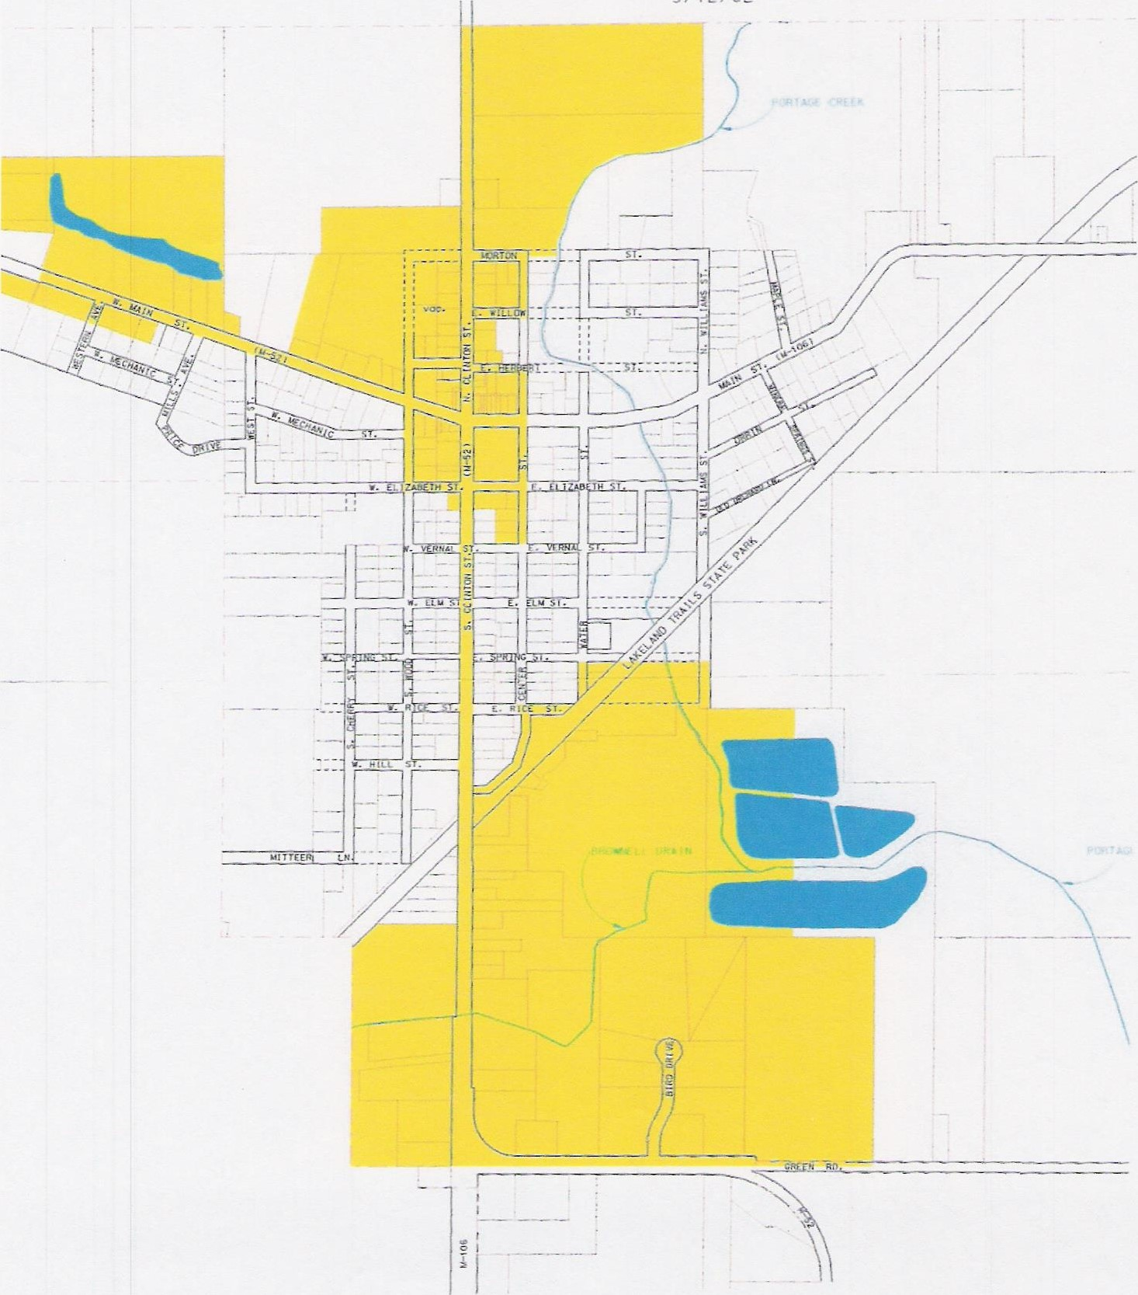
VILLAGE OF STOCKBRIDGE
NO SCALE
9/12/02

